

CAPSTON PROJECT

TOPIC – PRODUCT DISSECTION FOR PUBG



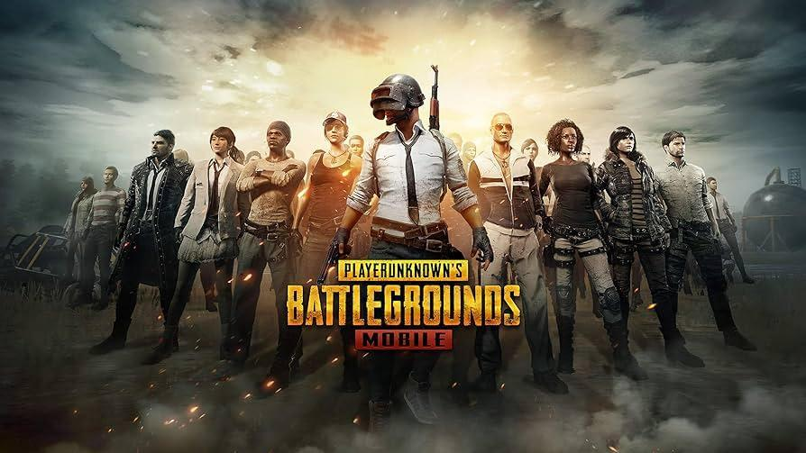

**SUBMITTED BY ,**

**NAME - T SUBAM**

**COHORT - ORLANDO**

**EMAIL_ID -** [**subhamrao7895@gmail.com**](mailto:subhamrao7895@gmail.com)

**TEAM - INDIVIDUAL**

**Product Dissection for PUBG :-**

**(Player Unknown's Battle Grounds)**

### **Company Overview:**

PUBG Mobile is a free-to-play battle royale video game developed by LightSpeed & Quantum Studio, a division of Tencent Games. It is a mobile game adaptation of PUBG: Battlegrounds. It was initially released for Android and iOS on 19 March 2018.

It was published by multiple publishers in different regions, including Krafton, Tencent, and VNG Games. By December 2023, PUBG Mobile had accumulated around 1.7 billion downloads while grossing over $9 billion. It is also the second most-played mobile video game of all time In 2021, the game spawned an Indian version, Battlegrounds Mobile India, and a separate game taking place in the PUBG Universe, called New State Mobile.

### **Product Dissection and Real-World Problems Solved by PUBG:**

PlayerUnknown's Battlegrounds (PUBG) is a widely popular multiplayer battle royale game that immerses players in intense, realistic combat scenarios. Developed by PUBG Corporation, the game drops a large number of players onto diverse maps, where they scavenge for weapons, navigate shrinking play zones, and engage in tactical firefights until only one individual or team remains. With a commitment to realism, PUBG features a variety of maps, realistic weapon mechanics, and strategic gameplay. Its success has led to the establishment of esports competitions, and the game is accessible across multiple platforms, including PC, console, and the highly successful mobile version, PUBG Mobile. PUBG's combination of engaging gameplay, regular updates, and a diverse global player base has solidified its position as a leading title in the battle royale genre.

### **Case Study: Real-World Problems and PUBG’s Innovative Solutions**

There isn't a specific documented real-world case study showcasing a problem and solution implemented by PUBG. However, I can offer a hypothetical scenario to illustrate how PUBG's mechanics might inspire innovative solutions in a real-world context.

#### **Problem 1:**

**Real-World Challenge:** Emergency response teams often face challenges in efficiently coordinating their efforts during crisis situations. Traditional communication methods can be slow, prone to errors, and may lack real-time information sharing capabilities.

**PUBG's Solution:** Inspired by PUBG's tactical communication and coordination features, a crisis management solution could be developed. This system would involve a dedicated mobile application used by emergency responders. Similar to PUBG's in-game communication tools, the app would facilitate real-time voice and text communication, allowing responders to coordinate strategies, share critical information, and update their locations instantly. The system could also integrate augmented reality (AR) for better situational awareness, enabling responders to visualize the crisis area and plan their actions collaboratively.

#### **Problem 2:**

**Real-World Challenge:** Training employees, especially in high-risk industries like manufacturing or emergency services, can be challenging due to the potential risks involved and the costs associated with real-world simulations. Traditional training methods may not fully capture the intensity and unpredictability of real-world scenarios.

**PUBG Solution:**

Taking inspiration from PUBG's immersive and intense gameplay, a virtual reality (VR) employee training and simulation platform could be developed. The platform would allow employees to train in realistic, simulated environments that mimic their actual work conditions. Similar to PUBG's in-game scenarios, employees would face dynamic challenges, emergencies, and decision-making scenarios, enhancing their ability to respond effectively in real-world situations. The VR training could be designed for various industries, providing a cost-effective and safe alternative to traditional training methods.

#### **Problem 3:**

**Real-World Challenge:** Urban planners often face challenges in designing public spaces that efficiently accommodate large crowds during events or emergencies. Traditional planning methods may struggle to predict and manage dynamic crowd behavior.

**PUBG’s Solution:**

Inspired by PUBG's dynamic play zones and crowd interactions, a simulation tool for urban planning and crowd management could be developed. This tool would use real-time data, including crowd movement patterns, to simulate various scenarios in public spaces. Planners could adjust parameters, such as the placement of facilities, exits, and seating arrangements, to optimize crowd flow and safety. Similar to PUBG's shrinking play zone, the tool could simulate different crowd densities and behaviors, helping planners make informed decisions to enhance the efficiency and safety of public spaces during events or emergencies.

**Problem 4:**

**Real-World Challenge:** During healthcare emergencies, such as pandemics or large-scale accidents, efficiently triaging patients and coordinating emergency responses can be complex. Traditional methods may face challenges in rapidly assessing and prioritizing patients based on severity.

**PUBG’s Solution:**

Taking inspiration from PUBG's dynamic and adaptive gameplay, a healthcare emergency response system could be designed. Emergency responders could use a dedicated mobile application equipped with augmented reality (AR) capabilities. Similar to PUBG's dynamic play zones, the app could use real-time data to assess the severity of medical incidents, allocate resources, and dynamically adjust the triage process. AR overlays could provide responders with vital information about patient conditions, available resources, and optimal routes for quick response. This system could enhance the efficiency of emergency response and improve patient outcomes during healthcare crises.

#### **Conclusion:**

In conclusion, while there may not be documented real-world case studies of PUBG directly addressing specific problems, the game's mechanics and features have the potential to inspire innovative solutions in various domains. The dynamic and adaptive nature of PUBG's gameplay, emphasis on communication, and real-time information sharing could serve as a creative catalyst for addressing real-world challenges. Hypothetical scenarios, such as crisis management, employee training, urban planning, and healthcare emergency response, demonstrate how PUBG's principles might be extrapolated for innovative solutions.

### 

### 

### 

### **Top Features of PUBG:**

**1. Player:**

The primary entity representing an individual player participating in the game.

**2. Matches:**

Games in PUBG are organized into matches, each with a specific duration and a goal of being the last player or team standing.

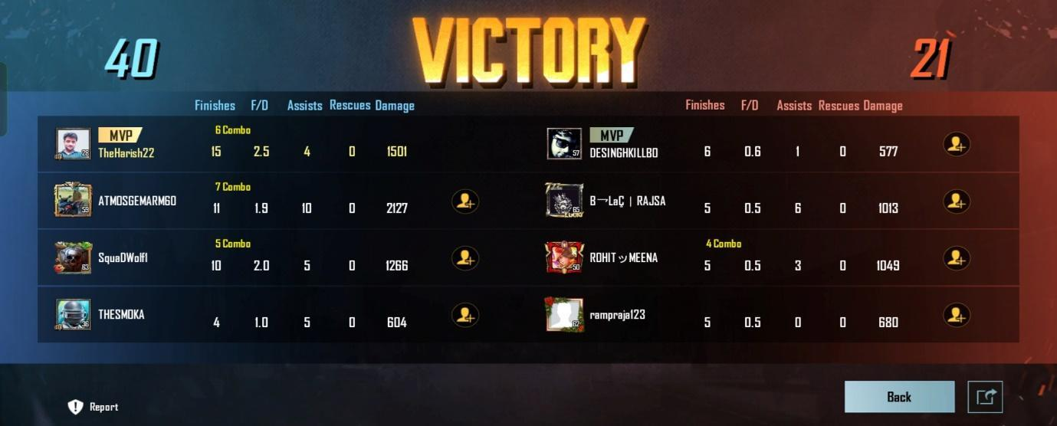

**3. Teams:**

Players can form teams, and team-based gameplay is a significant aspect of PUBG.

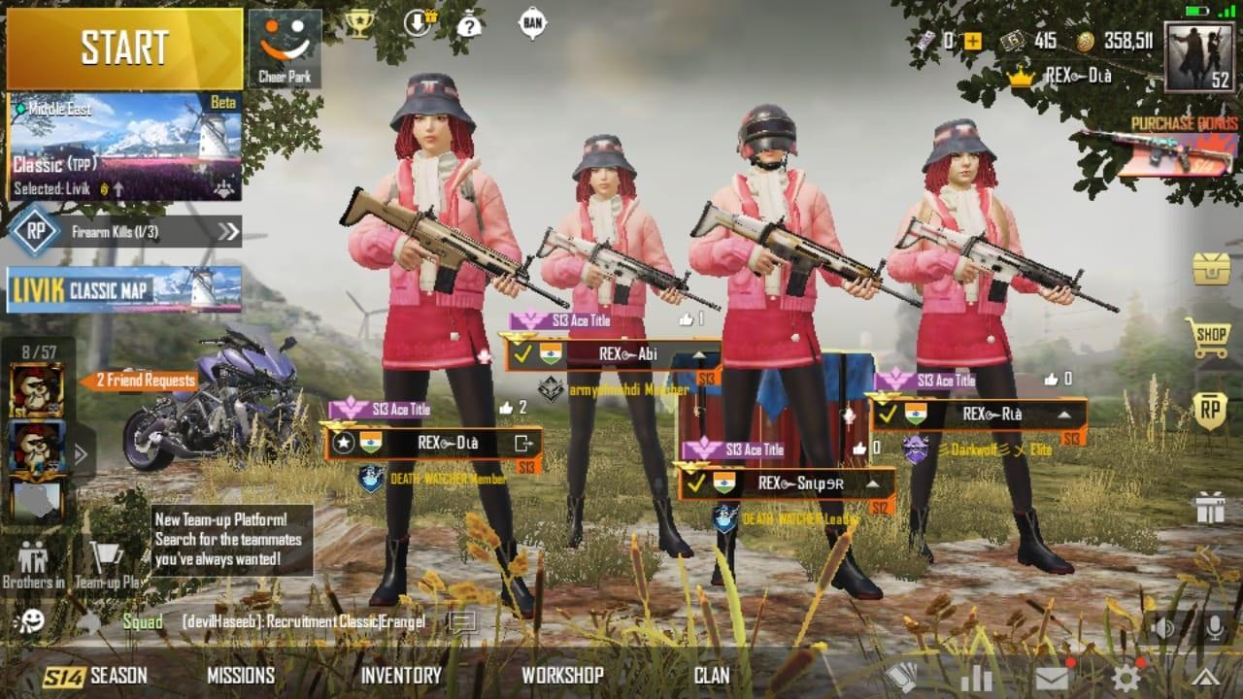

**4. Weapons and Equipment:**

PUBG features a wide array of weapons, attachments, and equipment that players can acquire during matches.

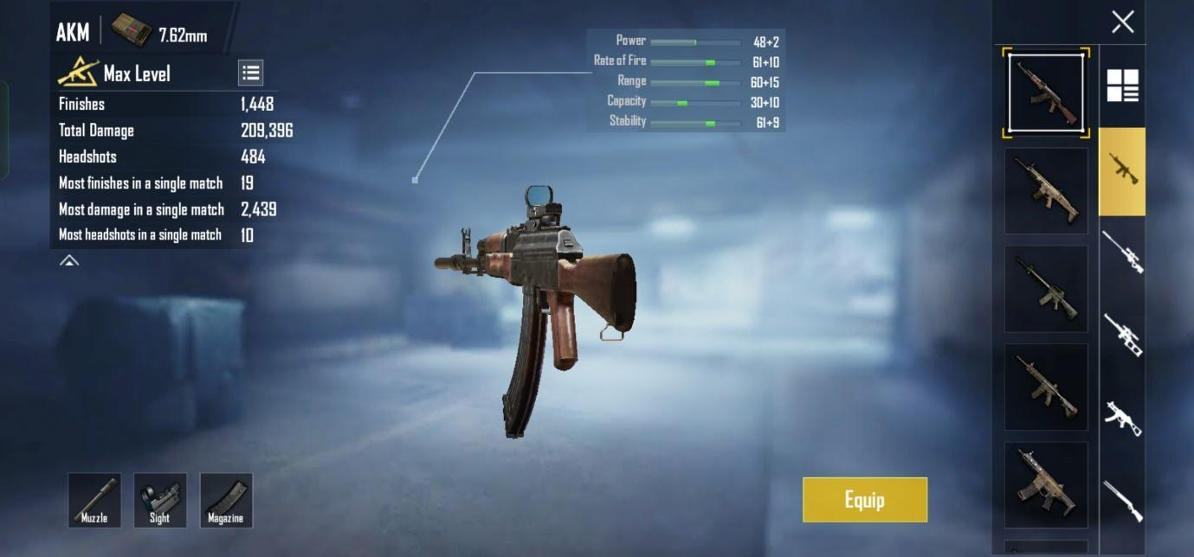

**5. Vehicles:**

Vehicles, such as cars, motorcycles, and boats, provide means of transportation across the large maps.

**6. Maps:**

PUBG has multiple maps, each with its own unique terrain, structures, and gameplay dynamics.

**7. Circle/Shrink Zone:**

The shrinking play zone (circle) is a dynamic element in PUBG, gradually reducing in size to force players into closer proximity, increasing the intensity of the game.

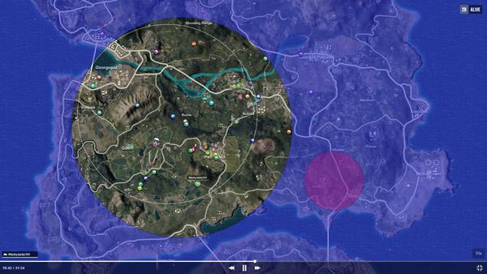

**8. Inventory:**

Players have an inventory where they manage items, weapons, and equipment collected during the match.

**9. Loot:**

Loot refers to items, weapons, and supplies scattered across the map for players to collect.

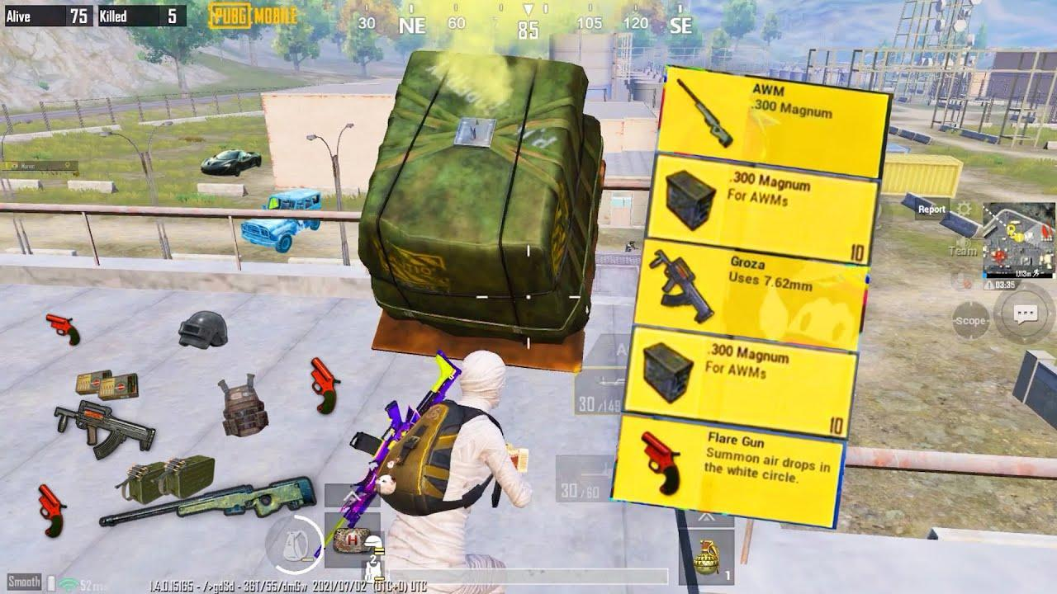

### **Schema Description:**

The schema for PUBG involves multiple entities that represent different aspects of the game. These entities include Player, Matches, Teams, Weapon and Equipments, Vehicles, Maps, and more. Each entity has specific attributes that describe its properties and relationships with other entities.

**1.Player Entity:**

Players are the core of Pubg. The user entity contains information about each user:

* **PlayerID (Primary Key):** A unique identifier for each player.
* **Username:** The player's chosen username or in-game handle.
* **Email:** The player's email address, often used for account authentication and communication.
* **PasswordHash:** A hashed version of the player's password for security.
* **DateJoined:** The date when the player created their account.
* **LastLogin:** Timestamp indicating the player's last login.

**2.Matches Entity:**

Matches are the important entity of PUBG:

* **MatchID (Primary key):** uniquely identifies each match.
* **MapName:** Name or identifier of the map used in the match.
* **MatchDuration:** Duration of the match in seconds.
* **WinningPlayerID (FOREIGN KEY):** Reference to the winning team (if applicable). For a free-for-all game, you might not need this.
* **TotalPlayers:** Total number of players in the match.

**3.Team Entity:**

describes a team in the context of your game:

* **TeamID (Primary key)**: Uniquely identifies each team.
* **TeamName:** The name or identifier of the team.
* **TeamScore:** An attribute to store the team's score, which might be useful in certain game contexts.

**4.PlayersTeam Entity:**

Refer To Creating a Team in the game:

* **PlayerID (Primary and Foreign Key):** Unique Id for Creating Team
* **TeamID (Foreign Key):** Identity of the team.

**5.Weapon Entity:**

Weapon used in the game:

* **WeaponID (Primary key):** Uniquely identifies each weapon.
* **WeaponName:** The name or identifier of the weapon.
* **WeaponType:** Describes the type or category of the weapon (e.g., assault rifle, shotgun, sniper rifle).
* **Damage:** The amount of damage the weapon inflicts per shot.
* **Range:** The effective range of the weapon.

**6.Equipment Entity:**

Equipment used in the game:

* **EquipmentID (Primary key):** Uniquely identifies each equipment item.
* **EquipmentName:** The name or identifier of the equipment.
* **EquipmentType:** Describes the type or category of the equipment (e.g., armour, helmet, backpack).
* **Durability:** The measure of how much damage the equipment can withstand before becoming unusable.

**7.PlayerWeapon Entity:**

Weapon used by player in the game:

* **PlayerID (Primary key and foreign key):** Uniquely identifies each player.
* **WeaponID (Foreign key):** Weapon id used by player.

**8.Vehicls Entity:**

Vehicles available in the game:

* **VehicleID (Primary key):** Uniquely identifies each vehicle.
* **VehicleName:** The name or identifier of the vehicle.
* **VehicleType:** Describes the type or category of the vehicle (e.g., car, motorcycle, boat).
* **Speed:** The speed or movement capability of the vehicle.
* **Capacity:** The maximum number of players or items the vehicle can carry.

**9.Maps Entity:**

Maps available in the game:

* **MapID (Primary key):** Uniquely identifies each map.
* **MapName:** The name or identifier of the map.
* **TerrainType:** Describes the type of terrain on the map (e.g., desert, forest, urban).
* **MapSize:** The size or dimensions of the map.
* **PlayerCapacity:** The maximum number of players the map can accommodate.

**10.Circle Entity:**

Playing circles which are restricted to the players:

* **CircleID (Primary key):** Uniquely identifies each circle.
* **MatchID (Foreign key):** Reference to the match to which the circle belongs.
* **Radius:** The current radius of the circle.
* **ShrinkRate:** The rate at which the circle shrinks.

**11.Inventory Entity:**

Inventory selected by the player:

* **InventoryID (Primary key):** Uniquely identifies each inventory item.
* **PlayerID (Foreign key):** Reference to the player who owns the inventory.
* **ItemName:** Reference to the item in the inventory.
* **Quantity:** The quantity of the item in the player's inventory.
* **Equipped:** A boolean value indicating whether the item is currently equipped by the player.

**12.Loot Entity:**

Loot from the map:

* **LootID (Primary key):** Uniquely identifies each loot item.
* **MapID (Foreign key):** Reference to the map where the loot item is located.
* **ItemName:** Reference to the specific item in the loot.
* **Quantity:** The quantity of the loot item available at that location.

## **Relationships are:**

**1.Player and team relationship:**

* One-to-Many relationship: One player can be a member of many teams, but each team can have only one leader.

**2.Player and MatchPlayer Relationship:**

* One-to-Many relationship: One player can participate in multiple matches, but each match has multiple players.

**3.Team and MatchTeam Relationship:**

* One-to-Many relationship: One team can participate in multiple matches, but each match can have multiple teams.

**4.Player and PlayerWeapon Relationship:**

* Many-to-Many relationship: One player can have multiple weapons, and one weapon can be owned by multiple players.

**5.Map and Circle Relationship:**

* One-to-One relationship: Each map has one circle, and each circle is associated with one map.

**6.Map and Loot Relationship:**

* One-to-Many relationship: Each map has multiple loot items.

**7.Match and Circle Relationship:**

* One-to-One relationship: Each match has one circle, and each circle is associated with one match.

**8.Item and Loot Relationship:**

* One-to-Many relationship: Each item can be found in multiple loot locations.

## **ER Diagram:**

Let's construct an ER diagram that vividly portrays the relationships and attributes of the entities within the PUBG schema. This ER diagram will serve as a visual representation, shedding light on the pivotal components of PUBG’s data model. By employing this diagram, you'll gain a clearer grasp of the intricate interactions and connections that define the platform's dynamics.

Gold key = Primary key, Blue tick = Foreign key

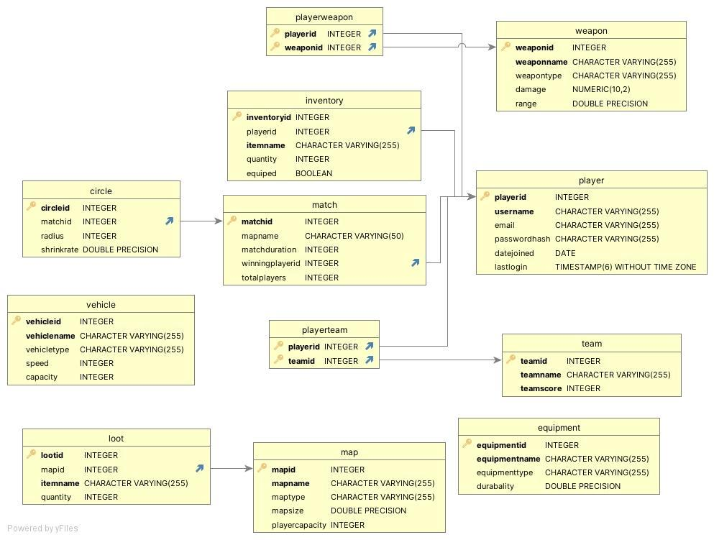

### **Conclusion:**

In conclusion, our PUBG product dissection has provided a comprehensive view of the game's architecture, design, and user experience. The analysis has unveiled both strengths and areas for improvement, offering valuable lessons for developers and enthusiasts alike. As PUBG continues to evolve, incorporating these insights could contribute to the ongoing success and innovation within the gaming industry.

THANK YOU